|  |  |  |  |  |  |
| --- | --- | --- | --- | --- | --- |
| Xώρος | Υποδικτυο | Μασκα | Broadcast | 1η IP | Last IP |
| Library | 192.168.5.0 | 255.255.255.192 | 192.168.5.63 | 192.168.5.1 | 192.168.5.62 |
| Library | 192.168.5.64 | 255.255.255.192 | 192.168.5.127 | 192.168.5.65 | 192.168.5.126 |
| Staff | 192.168.5.128 | 255.255.255.192 | 192.168.5.191 | 192.168.5.129 | 192.168.5.190 |
| Staff | 192.168.5.192 | 255.255.255.192 | 192.168.5.255 | 192.168.5.193 | 192.168.5.254 |

|  |  |  |  |  |  |
| --- | --- | --- | --- | --- | --- |
| S1 – Switch Σχολείου | | | | | |
| Port | Interface | IP | Mask | Gateway |  |
| Fa 0/1 | PC0 | 192.168.5.1 | 255.255.255.192 | 192.168.5.11 | 192.168.1.6 |
| Fa 0/2 | PC1 | 192.168.5.2 | 255.255.255.192 | 192.168.5.11 | 192.168.1.6 |
| Fa 0/3 | PC2 | 192.168.5.3 | 255.255.255.192 | 192.168.5.11 | 192.168.1.6 |
| Fa 0/4 | PC3 | 192.168.5.4 | 255.255.255.192 | 192.168.5.11 | 192.168.1.6 |
| Fa 0/5 | PRN | 192.168.5.5 | 255.255.255.192 | 192.168.5.11 | 192.168.1.6 |
| Fa 0/6 | SRV1 | 192.168.5.6 | 255.255.255.192 | 192.168.5.11 | 192.168.1.6 |
| Fa 0/7 | PC4 | 192.168.5.132 | 255.255.255.192 | 192.168.5.130 | 192.168.1.6 |
| Fa 0/8 | PC5 | 192.168.5.129 | 255.255.255.192 | 192.168.5.130 | 192.168.1.6 |
| Fa 0/9 | LAP | 192.168.5.131 | 255.255.255.192 | 192.168.5.130 | 192.168.1.6 |
| Gig 0/1 | R1 Σχολείου | Trunk | | | |

|  |  |  |  |  |  |
| --- | --- | --- | --- | --- | --- |
| Port | Interface | IP | Mask | Gateway | DNS |
| Gig0/0/0.1 | S1–switch sχολείου G0/1 | 192.168.5.11 | 255.255.255.192 |  |  |
| Gig0/0/0.2 | 192.168.5.130 | 255.255.255.192 |  |  |
| Gig0/0 | DSL Modem/Cloud – Router ΠΣΔ | 81.186.127.2 | 255.255.128.0 |  |  |

**Σημείο Ελέγχου #1:**

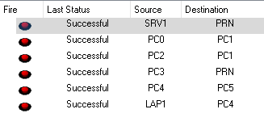

Τα ports FastEthernet0/1 – FastEthernet0/23 καθώς και το GigabitEthernet0/1 έχουν απενεργοποιηθεί όπως θα φανεί και στο Config Tab του S1

**Σημείο Ελέγχου #2:**

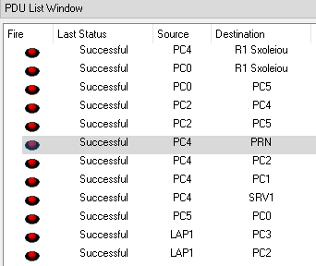

**Σημείο Ελέγχου #3:**

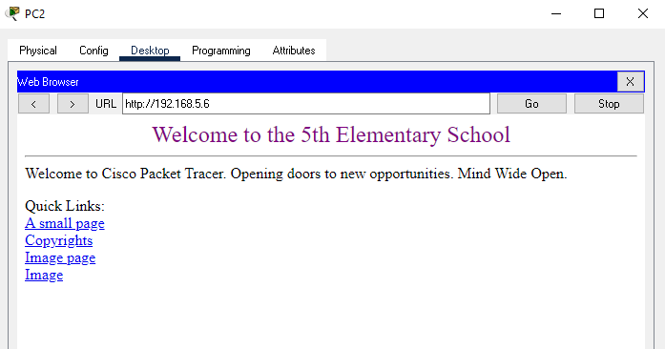

**Σημείο Ελέγχου #6:**

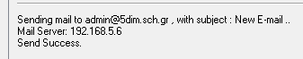

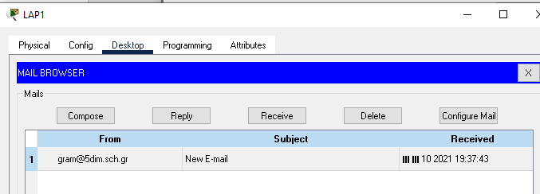

|  |  |  |  |  |  |
| --- | --- | --- | --- | --- | --- |
| S2-Switch | | | | | |
| Port | Interface | IP | Mask | Gateway | DNS |
| Fa0/1 | Srv2 – PSD Server | 194.63.235.2 | 255.255.255.0 | 194.63.235.1 |  |
| Gig0/1 | R2 PSD | 194.63.235.1 | 255.255.255.0 | 194.63.235.1 |  |

|  |  |  |  |  |  |
| --- | --- | --- | --- | --- | --- |
| R2 - Router | | | | | |
| Port | Interface | IP | Mask | Gateway | DNS |
| Gig 0/0 | Cloud/Dsl  Modem/Router | 81.186.0.1 | 255.255.128.0 | 194.63.235.1 |  |
| Gig 0/1 | S2 | 194.63.235.1 | 255.255.255.0 | 194.63.235.1 |  |
| Se 0/2/0 | R3 GRNET | 12.0.0.1 | 255.255.255.0 | 194.63.235.1 |  |